- Calculate the area of the figures below. Show your thought process.

a.) b.) c.)
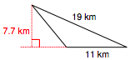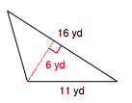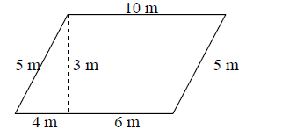

- Draw a trapezoid with a right angle and an area greater than 50 square feet.

- Draw a trapezoid with no right angles and an area greater than 75 square meters.

