**Systems of Equations Review Sheet Name: ________________________________**

1. A boat travels 45 miles upstream (against the current) in 5 hours. The boat travels the same distance downstream in 3 hours. What is the rate of the boat in still water? What is the rate of the current?



1. José had 4 times as many trading cards as Philippe. After José gave away 50 cards to his little brother and Philippe gave 5 cards to his friend for his birthday, they each had an equal amount of cards. Write a system to describe the situation and solve the system.
2. An Algebra test is worth 100 points and has 25 questions. There are multiple choice questions worth 3 points each and short answer questions worth 8 points each. How many short answer questions are on the test?



1. With the wind, A USAir flight flew 1980 miles in 6 hours. On the return trip, the pilot was forced to land after 2 hours, having traveled only 440 miles. Find the rate of the plane in still air and the rate of the wind.



1. The total value of $5 bills and $10 bills in the cash box is $410. There are eight more $10 bills than $5 bills. How many $10 bills are there in the cash box?



1. On an upstream trip, a canoe travels 40 km in 5 hours. Downstream, it travels the same distance in half the time.
   1. What is the rate of the canoe in still water and what is the rate of the current?



* 1. How long would it take the canoe to travel 100 km in still water? ___________________________

1. Four years ago, Katie was twice as old as Anne was then. In 6 years, Anne will be the same age that Katie is now. How old is each person now?



1. Larry is 8 years older than his sister. In 3 years, he will be twice as old as she is now. How old are they now?



1. At Pizzazz Pizza, the total price for 5 large pizzas and 2 medium pizzas is $81.50. The total for 4 large pizzas and 3 mediums pizzas is $78.50. What is the price of a medium pizza?



1. The number of calories in a piece of cake is 20 less than 3 times the number in a scoop of ice cream. The cake and ice cream together have 620 calories. How many calories are in each?



1. A change purse contains a total of 70 quarters and dimes. The total value of the coins is $9.40. How many coins of each type does the purse contain?



1. Given that the sum of two numbers is 10 and their difference is 4, what are the numbers?



1. A restaurant serves a vegetarian and a chicken lunch special each day. Each vegetarian special is the same price. Each chicken special is the same price. However, the price of the vegetarian special is different from the price of the chicken special.

• On Thursday, the restaurant collected $467 selling 21 vegetarian specials and 40 chicken specials.

• On Friday, the restaurant collected $484 selling 28 vegetarian specials and 36 chicken specials. What is the cost of each lunch special?



1. The senior classes at High School A and High School B planned separate trips to New York City. The senior class at High School A rented and filled 1 van and 6 buses with 372 students. High School B rented and filled 4 vans and 12 buses with 780 students. Each van and each bus carried the same number of students. How many students can a van carry? How many students can a bus carry?



1. Brenda's school is selling tickets to a spring musical. On the first day of ticket sales the school sold 3 senior citizen tickets and 9 child tickets for a total of $75. The school took in $67 on the second day by selling 8 senior citizen tickets and 5 child tickets. What is the price each of one senior citizen ticket and one child ticket?



1. The cost of 5 squash and 2 zucchini is $1.32. Three squash and 1 zucchini cost $0.75. Find the cost of each vegetable.



1. 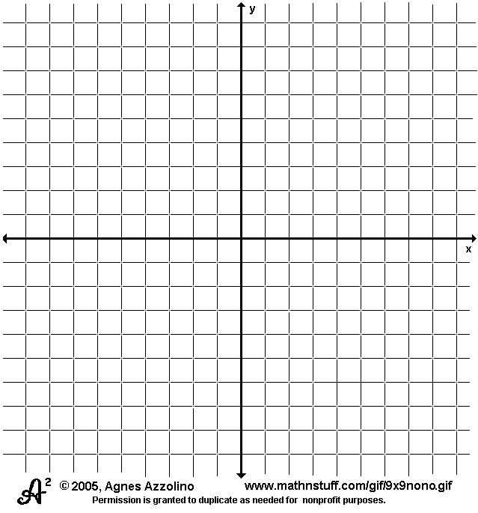**The Gondola Company charges just $0.10 per minute, but it costs $23 to get a boat. Express Boat charges no fee to get in, but $1.25 per minute.**
   1. Write two equations to model the above situation and then make a graph of your equations.
   2. If you are going 10 minutes, which gondola company should you call?
   3. If you are going 30 minutes, which company should you call?
   4. For what length of time is the cost equal?
2. **The Timeless Trolley costs $1 per mile. Turbo Trolley charges $0.50 a mile for a ride plus a $10 initial fee.**
   1. Write two equations to model the above situation and then make a graph of your equations.



* 1. If you are going 25 miles, which trolley company should you call?
  2. If you are going 15 miles, which company should you call?
  3. For what length of drive is the cost equal?

1. **The Big Cab Company charges just $0.20 a mile and $12 to get in the cab. Fast Cab charges no fee to get in, but $1.40 a mile for a ride.**
   1. Write two equations to model the above situation and then make a graph of your equations.



* 1. If you are going 5 miles, which cab company should you call?
  2. If you are going 15 miles, which company should you call?
  3. For what length of drive is the cost equal?

**Solve each system by graphing.**

**20. $\left\{\begin{aligned}y=2x-4 \\ 3y = 6x - 12\end{aligned}\right.$ 21. $\left\{\begin{aligned}2y =-4x+4 \\ 2y = -6x + 2\end{aligned}\right.$**  **22.**



____________________ ____________________ ______________________

**Solve each system using substitution or elimination.**

**23. $\left\{\begin{aligned}2x -4y= -4 \\ x - y = 1\end{aligned}\right.$** **24. $\left\{\begin{aligned}2x -3y = 14 \\ 7x + 3y = 4\end{aligned}\right.$**  **25. $\left\{\begin{aligned}0.3x -0.4y=1.2 \\ 0.5x + 0.3y = - 0.2\end{aligned}\right.$**

_______________________ ________________________ _________________________

**26. $\left\{\begin{aligned}-2x+y=-17 \\ 4x - 2y = 34\end{aligned}\right.$ 27. $\left\{\begin{aligned}3x +y+1 = 0 \\ 5x – y – 17 = 0\end{aligned}\right.$**  **28. $\left\{\begin{aligned}5x + y= 11 \\ 2x + 6y= -18\end{aligned}\right.$**

_______________________ _______________________ _________________________

**Give the best method to solve each system. Then, use that method to solve the system.**

**29. $\left\{\begin{aligned}\frac{7}{4}y = x \\ 4x + 3y = 19\end{aligned}\right.$ 30. $\left\{\begin{aligned}3x+4y=10 \\ -3x – 3y = 7\end{aligned}\right.$ 31. $\left\{\begin{aligned}2x+3y=12 \\ -5x+4y=10\end{aligned}\right.$**

_______________________ _______________________ _________________________

**32.** Give an example of a system of equations with no solution and a separate system of equations with infinitely many solutions.

**a.** What are the characteristics of no solution systems of equations? Use your example as evidence to support your response.

**b**. What are the characteristics of infinitely many solutions’ systems of equations? Use your example as evidence to support your response.