Algebra Mid-Term Review |  |  |  | Name: ______________________________
__ | 1. | The first 5 terms of a sequence are 4, 10, 16, 22, 28,...  Which of these are the correct recursive definitions of this sequence? Select all that are correct.
a) a₁ = 4; a_{n} = a_{n-1} + 6 b) a₁ = 4; a_{n} = a_{n+1} + 6
c) a₁ = 4; a_{n+1} = a_{n} + 6 d) a₁ = 4; a_{n+1} = a_{n-1} + 6

__ | 2. | The first term of the arithmetic sequence below is equal to 2.  2, 7, 12, 17, 22, 27, …  Which term of the sequence is equal to 137?
 |  | - 28th b) 27th c) 26th d) 25th
__ | 3. | Which function(s) would NOT have the set {–3, –1, 0, 3, 6} as part of its domain and range? Select all that apply.
- b) c) d)
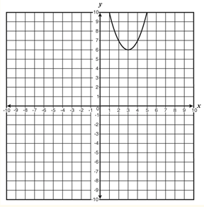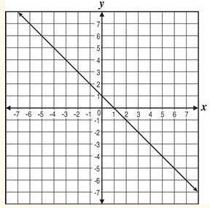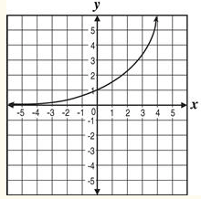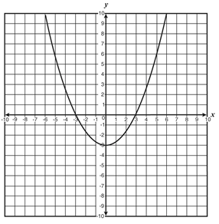

__ | 4. | The surface area A of a sphere is $A=4πr^{2}$, where r is the radius of the sphere. What is the radius, rounded to the nearest tenth, of a ball with surface area equal to 85 square inches?
 |  | a) 2.6 in b) 2.7 in c) 6.7 in d) 6.8 in
__ | 5. | 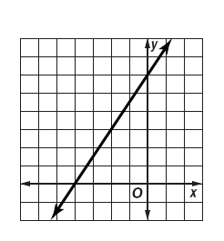  What is the equation of the line shown?  a) $3x + 2y = 12$ b) $3x – 2y = 12$  c) $3x + 2y = -12$ d) $3x – 2y = -12$
__ | 6. | If$f(x) = 4x – 5$, find $f(3a + 1).$
 |  | a) $12a – 4$ b) $7a – 4$ c) $12a – 1$ d) $12a + 4x – 5$
__ | 7. | A line passes through (-1, 3) and (1, -3). Which equation does not represent the line?
 |  | a) $(y – 3) = -3(x + 1)$ b) $3x – y = 0$ c) $(y + 3) = -3(x – 1)$ d) $y = -3x$
__ | 8. | Dave graphed the linear function with an x-intercept of 4 and a y-intercept of 12. Which function did Dave graph?
 |  | a) $y=-4x+12$ b)$y=4x-12$ c)$y=-3x+12$ d) $y=3x-12$
__ | 9. | Solve for $B$. $A = \frac{2}{3}(40 – B)$
 |  | a) $B = 40 – \frac{2}{3}A$ b) $B = \frac{3}{2}A – 40$ c) $B = 60 – \frac{3}{2}A$ d) $B = 40 – \frac{3}{2}A$

__ | 10. | Which ordered pair is a solution of the system $4x – 8y≥ 24$ and $2x – 3y > 18$?
 |  | - (7, -1) b) (-5, -4) c) (2, -5) d) (-8, -8)
__ | 11. | Jane and Mack were flying drones. J(t) represents the height of Jane’s drone and M(t) represents the height of Mack’s drone at time, t. Over the interval $5 ≤t≤10$Jane’s drone height was higher than Macks. Which statement below correctly compares Jane and Mack’s drone heights from 5 to 10 seconds?  a) J(5) = M(5) b) J(8) > M(8) c ) J(12) > M(12) d) J(7) < M(7)
__ | 12. | The amount of flour, f, needed for n batches of cookies is the product of n and three cups of flour per batch. Which equation describes this?
 |  | a) f = 3n b) fn= 3 c)$f= \frac{3}{n}$ d)$f= \frac{n}{3}$
__ | 13. | Mechanic Mike uses the following equation when calculating charges for his customers:  C = 75h + 100, where C represents the total charge and h the number of hours he worked on the vehicle. What does the y-intercept represent in this situation?
a) Initial diagnostic fee b) The per hour fee
c) The number of hours Mike worked on the vehicle d) The total charges

__ | 14. | What would the slope of a line perpendicular to 2x + 5y = 7 be?
 |  | a)$-\frac{2}{5}$ b) $\frac{5}{2}$ c) $\frac{2}{5}$ d) $-\frac{5}{2}$
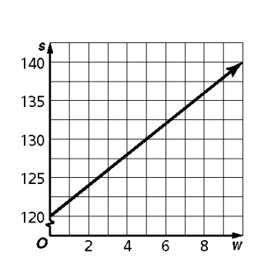
Use the following information for questions 15 and 16:

Jovita has 120 subscribers on her mailing list. She predicts that each week, 3 subscribers will join and 1 will leave. The graph illustrates how the number of subscribers increases. Use the graph to answer the following questions.

__ 15. Which is the slope of the line that contains the points on the graph?

a) -20 b) -2 c) 2 d) 120
__ | 16. | What does the slope of the line represent?
a) the increase in subscribers each week b) the initial number of subscribers
c) the cost of the subscription d) the number of months Jovita has run the mailing list

__ | 17. | Which equation is parallel to the line containing the points (-5, 2) and (2, -1)?
 |  | a) $3x – 7y = 14$ b) $7x – 3y = 9$ c) $-3x + 7y = 7$ d) $3x + 7y = 12$
___ | 18. | If $5x + 3y = 12$ and $4x – 5y = 17$, what is the value of y?  - $-1$ b.) $3$ c.) $2$ d.) $-3$
__ | 19. | The function below describes an arithmetic sequence, where A(n) is the nth term and n is the term number.  A(n) = 6 + 3(n – 1)  Which table best fits the sequence?
- b) c) d)
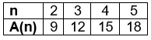
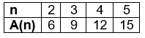
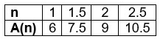
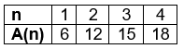

__ | 20. | Which set of data is nonlinear?
a) b) c) d)
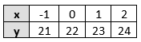
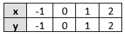
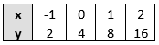
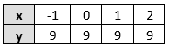

__ | 21. | 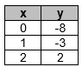  Which equation represents the ordered pairs shown in the table?
 |  | a)$y = -8x$ b) $y = 5x – 8$ c) $y = x – 8$ d) $y = 3x + 8$
__ | 22. | What are the x- and y-intercepts of the graph of $7y- \frac{1}{2}x=14$ ?
a) $x-intercept=-2;y-intercept=28$ c) $x-intercept=28;y-intercept=-2$

b) $x-intercept=2;y-intercept=-28$ d) $x-intercept=-28;y-intercept=2$
___ 23. Simplify. Assume that no denominator is equal to zero.
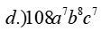
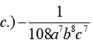
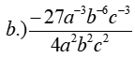
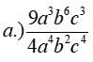

___ 24. Solve the equation.
- -1 b.) 5 c.) ¾ d.) no solution
___ 25. James is selling pens and pencils to his friends. Allen bought 2 pencils and 7 pens for $1.16 while Maria bought 3 pencils and 5 pens for $0.97. How much does each pencil cost?
- $0.11 b.) $0.14 c.) $0.09 d.) $0.08
___ 26. Determine the value of r so the line that passes through (-2, r), (10, 4) has a slope of.
- r = 20 b.) r = 10 c.) r = 5 d.) r = 2.5

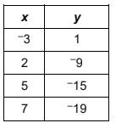
___ 27. Sarah compared the function y = 7x + 13 to the linear function that fits the values in the table to the right.
What is the distance between the y-intercepts of the two functions?
- 5 b.) 9 c.) 13 d.) 18

___ 28. What is the value for f(-3) when f(x) = $2x^{2}- 7x-4$?
- $-1$ b.)$35$ c.)$53$ d.)$-7$
Solve the following questions. Show all your work.
___ 29. The length of a rectangular table is 3 times the width. The perimeter of the table is 288 inches. What is the length of the table?
___ 30. Eula Jones is investing $10,000 in two accounts, part at 4.5% and the remainder at 6%. If the total interest for one year is $540, how much is invested in the 6% account?
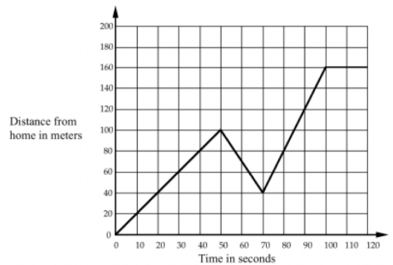
31. USING GRAPH PAPER, draw a graph showing time vs. speed of a person walking around the block three times at a constant speed.
32. Write a scenario that could be represented by the graph to the right.
- Ellie is spending the night at a hotel for a week that charges her an initial booking fee of $20 and then $110 per night. Identify the domain and range of the scenario using set notation.

- For the function f(x) below, answer the following. You may have to approximate some answers.
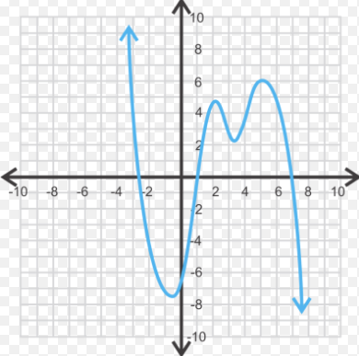
- f(7) a. ______________
- f(-3) b. ______________
- f(x)= 3, then find all values of x. c. ______________
- f(x)= 5, then, find all values of x. d. ______________
- What is the y-intercept? e. ______________
- How many x-intercepts? f. ______________
- How many maximums occur over the domain
-1$≤x≤6$? g. ______________
- How many minimums occur over the range $2≤x≤8$? h. ______________

- What is the average rate of change for the function over the interval $-3 ≤x≤-2$
i. ______________

