Calculator Inactive EOG Practice Name: _______________________________
- What is the value of (8² – 15) $÷$ 8 x 3⁴?

- Which expression is equivalent to 12g – 18h?
  - 6(2g – 18h) b. 6(2g – 3h) c. 6(6g – 12h) d. 6(6g – 18h)

- Mary has an after school job. She earns $9.75 per hour. She has worked 15 hours per week for 6 weeks. How much money has she earned?

- Jake will cut a candy bar that is 6 $\frac{1}{4}$ inches long into $\frac{1}{8}$ inch sections. How many sections will result?

- Kim and Michelle are debating the answer to the equation $\frac{3}{5}x= \frac{1}{6}$ .
-Michelle states that x is equal to $\frac{5}{18}$.
-Kim states that x is equal to 3$\frac{3}{5}.$
Which statement is true?
- Michelle’s answer of 5/18 is correct because she used the multiplicative inverse by multiplying 1/6 by 5/3 to get her answer.
- Michelle’s answer of 5/18 is correct because she multiplied 1/6 by 3/5 to get her answer.
- Kim’s answer of 3 3/5 is correct because she used the multiplicative inverse by multiplying 3/5 by 6 to get her answer.
- Kim’s answer of 3 3/5 is correct because she divided 3/5 by 1/6 to get her answer.

- Troy pays $450 each month to rent his apartment. He earns $35 per hour at his job. Which equation represents Troy’s profit, y, for working x hours?
  - y = 35x – 450
  - y = 35x + 450
  - y = 35 + 450x
  - y = 35 – 450x

- Which box plot represents the data? 135, 149, 156, 112, 134, 141, 154, 116, 134, 156
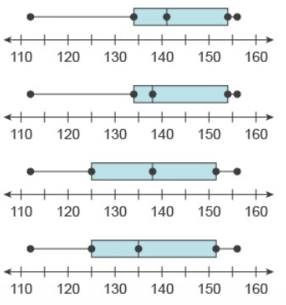

- Which box plot represents the set of data with the largest interquartile range?
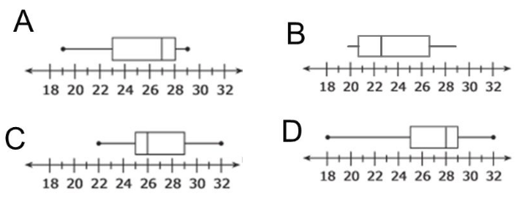

- Which ordered pair represents a reflection of the point (–4, 7) across the x-axis?
  - (-4, 7) b. (4, 7) c. (4, -7) d. (-4, -7)

- Which statement is true?
  - 9.3 < 9.03 b. 0.09 < 0.009 c. 3.$\overline{6}$ < 3.67 d. 0.0$\overline{4}$ < 0.04

- Sarah walks the same number of miles to school, x, each school day. Her total distance for one school week (5 days) is less than 10 miles. Which inequality represents how many miles Sarah walks each day?
  - 5x < 10 b. 5x > 10 c. x + 5 < 10 d. x + 5 > 10

- What is the value of $\left(7x+\frac{1}{3}\right)$² when x = 1?
Only 0, 1, 2, 3, 4, 5, 6, 7, 8, 9, . , -, and / are allowed in your answer.
Answers that are mixed numbers must be entered as an improper fraction or
decimal.

- During the weekend at the Wells Fargo Championship golf tournament every 40th person to enter the gift shop received a key chain.
- On Saturday, 1,350 people entered the gift shop.
- On Sunday, 1,690 people entered the gift shop.
How many people received a gift card?
Only 0, 1, 2, 3, 4, 5, 6, 7, 8, 9, . , -, and / are allowed in your answer. Answers that are mixed numbers must be entered as an improper fraction or decimal.

- John bought gas for his car. He paid $2.89 per gallon. He bought 14.7 gallons. What was the total cost for John’s gas? Express the answer as dollars.cents.

- What is the value of 13,408 ÷ 10⁴?

- Sam has 3 ¼ cups of sugar. He is making a recipe that calls for 1/8 cup of sugar. What is the maximum number of times Sam can complete the recipe?

