Course 1 Benchmark Test – End of Year

1. Which rule best describes the relationship shown in the function table below?
Input | Output
1 | 3
2 | 6
3 | 9
4 | 12
5 | 15

A. subtract 2

B. add 2

C. divide by 3

D. multiply by 3

2. Marcus needs to earn a grade higher than 88 on his final quiz in order to have an A average. Which inequality best represents this situation?

F. g ≥ 88

G. g > 88

H. g < 88

I. g ≤ 88

3. SHORT ANSWER Define a variable and write an expression to represent the following phrase.

a number increased by 5

4. What is the least common multiple of 8 and 14?

A. 56

B. 28

C. 4

D. 2

5. What is the volume of the rectangular prism shown below?
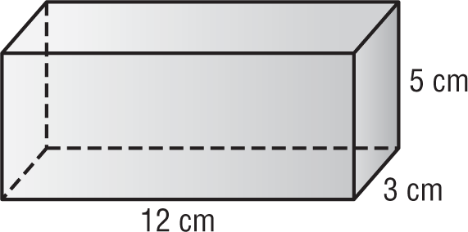

F. 20 ${cm}^{3}$

G. 75 ${cm}^{3}$

H. 180 ${cm}^{3}$

I. 222 ${cm}^{3}$

6. The list below shows the number of books read by students in Abram’s class over the summer. What is the mode of the data?

3, 6, 12, 4, 3, 5, 4, 8, 4, 10, 4, 8, 7, 5, 7

A. 4 books

B. 5 books

C. 7 books

D. 9 books

Course 1 Benchmark Test – End of Year (continued)

7. Which type of data display would be best for showing how data change over time?

F. box plot

G. histogram

H. line graph

I. line plot

8. There are 65 people watching a movie at a theater. If 40% of the customers purchased refreshments for the movie, how many customers purchased refreshments?

A. 26 customers

B. 34 customers

C. 39 customers

D. 163 customers

9. Adeline is wrapping a gift for her mother in a box with the dimensions shown.
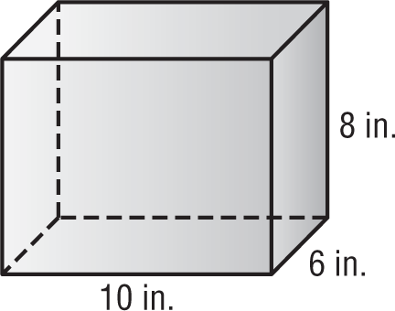

What is the minimum amount of wrapping paper Adeline will need to completely cover the gift box?

F. 188 square inches

G. 376 square inches

H. 424 square inches

I. 488 square inches

10. The ratio table shows the number of miles Karen can drive for 1, 2, 3, and 4 gallons of gasoline. Based on the table, how far would she be able to drive on 8 gallons of gasoline?
Gallons | 1 | 2 | 3 | 4
Distance (mi) | 30 | 60 | 90 | 120

A. 30 mi

B. 150 mi

C. 210 mi

D. 240 mi

11. SHORT ANSWER Emily made 14 out of 19 shots during basketball practice. About what percent of her shots did she make? Explain your reasoning.

12. A muffin recipe calls for a ratio of 5 cups of flour to 2 cups of sugar. For each cup of sugar that is used, how many cups of flour are needed?

F. $\frac{5}{2}$ cups of flour

G. $\frac{5}{7}$ cups of flour

H. $\frac{2}{5}$ cup of flour

I. $\frac{2}{7}$ cup of flour

Course 1 Benchmark Test – End of Year (continued)

13. SHORT ANSWER The line graph shows the number of members during the first few months
of a photography club. Describe the data. Then predict the number of members for the sixth month.
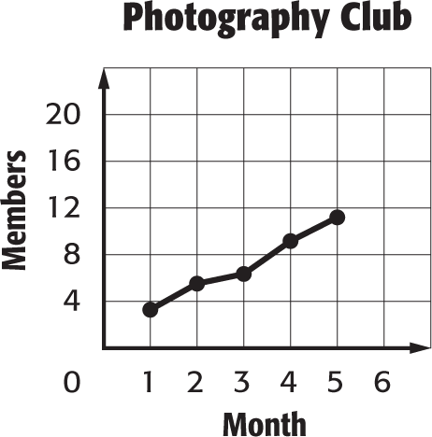

14. The table shows the number of points Anna scored this season. Find the mean number of points Anna scored.
Points Scored
12 | 7 | 9 | 10
16 | 6 | 8 | 15
12 | 11 | 12 | 14

A. 9 points

B. 10 points

C. 11 points

D. 12 points

15. Which of the following integers has the least absolute value?

F. –3

G. 4

H. 8

I. –12
16. Albert purchased 2.4 pounds of mixed nuts for $4.79 per pound. How much did he spend in all,
to the nearest cent?

A. $12.43

B. $11.50

C. $6.71

D. $1.99

17. Which of the following coordinate pairs corresponds to point A?
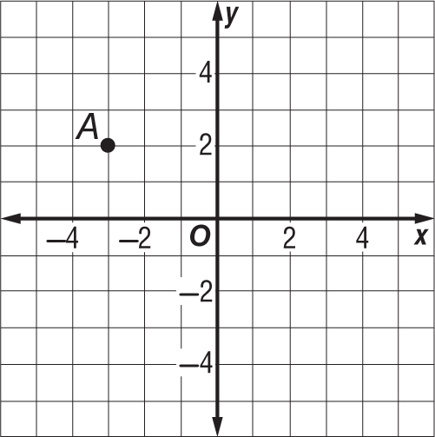

F. (2, –3)

G. (3, –2)

H. (–2, 3)

I. (–3, 2)

18. Which of the following symbols, when placed in the blank, makes the number sentence true?

$\frac{20}{75}$ _____0. $\overline{26}$

A. +

B. =

C. <

D. >

Course 1 Benchmark Test – End of Year (continued)

19. What is the volume of the triangular prism?
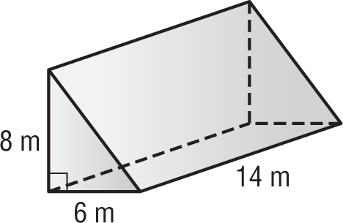

F. 336 cubic meters

G. 384 cubic meters

H. 672 cubic meters

I. 724 cubic meters

20. The line plot shows the quiz scores of several students.
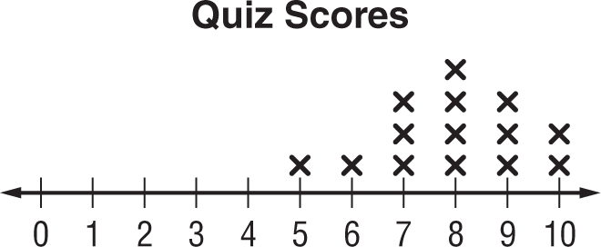

What is the range of the quiz scores?

A. 4 points

B. 5 points

C. 7 points

D. 8 points

21. Julio is evaluating the expression below.
6 + 2(9 – 4) – 3 × 5
Which operation should be performed first according to the order of operations?

F. Add 6 and 2.

G. Multiply 2 by 9.

H. Subtract 4 from 9.

I. Multiply 3 by 5.

22. Which property is represented by the equation shown below?
6 × 3 = 3 × 6

A. Multiplicative Inverse Property

B. Multiplicative Identity Property

C. Associative Property of Multiplication

D. Commutative Property of Multiplication

23. The algebra mat below models the equation
x – 2 = 4.

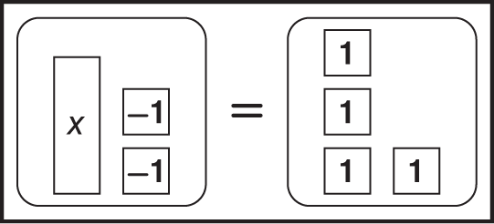

What is the solution to the equation?

F. 6

G. 2

H. –2

I. –8

24. SHORT ANSWER Graph the figure with the vertices A(2, –1), B(6, –1), and C(6, 4). Then classify the figure.
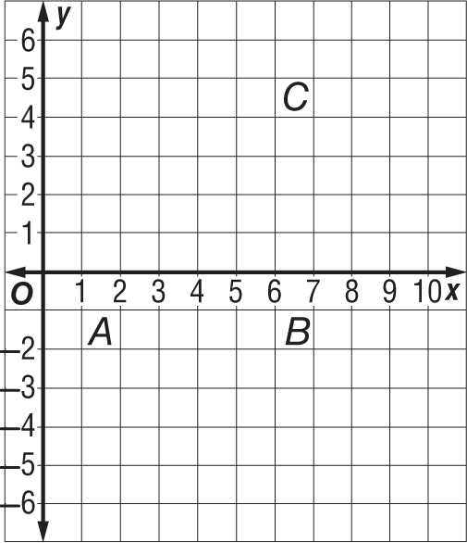

Course 1 Benchmark Test – End of Year (continued)

25. Which number line shows the solution to the inequality x − 3 ≤ 1?

A.
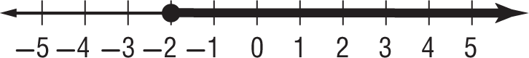

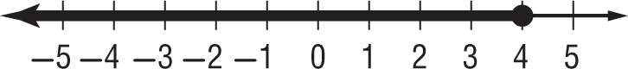
B.

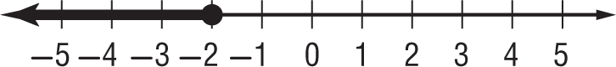
C.

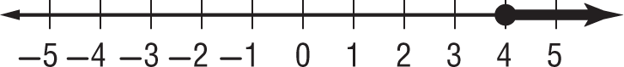
D.

26. The box plot shows the daily attendance at a fitness class.

Fitness Class Attendance
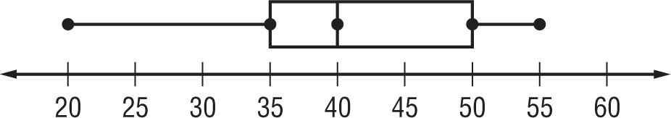

What is the median of the data?

F. 55

G. 40

H. 35

I. 20

27. What value of x results in a true number sentence in the equation shown?
2x = 16
A. 32

B. 14

C. 8

D. 4

28. Which of the following equations represents the function graphed on the coordinate plane?
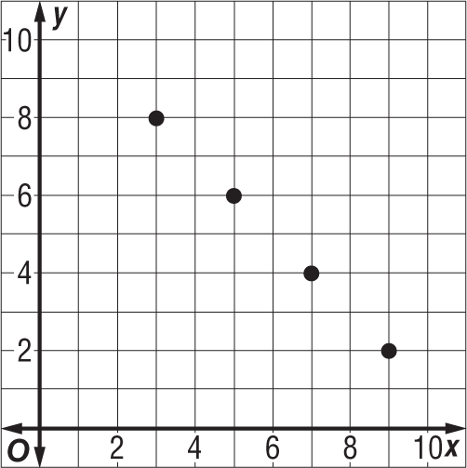

F. y = x + 5

G. y = x + 1

H. y = 11 + x

I. y = 11 – x

29. SHORT ANSWER The table below shows computer prices at an electronics store.
Computer Prices ($)
950 | 620 | 545 | 810
775 | 1,120 | 905 | 775

Find the mean absolute deviation to the nearest cent. Explain what this value represents.

Course 1 Benchmark Test – End of Year (continued)

30. The table below shows the type and number of vehicles in a parking lot
.
Types of Cars
Minivans | 12
Sedan | 28
SUV | 9
Trucks | 5

What is the ratio of sedans to minivans in simplest form?

A. 7 to 3

B. 3 to 7

C. 7 to 10

D. 10 to 3

31. The expression rt can be used to find the distance traveled by an object that has an average speed of r over time t. How many miles will a hot air balloon travel in 2.2 hours if it travels at an average speed of 12.5 miles per hour?

F. 30.1 miles

G. 27.5 miles

H. 14.7 miles

I. 5.7 miles

32. What is the area of the triangle?
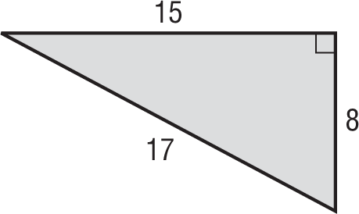

A. 120 square units

B. 75 square units

C. 60 square units

D. 40 square units
33. SHORT ANSWER The table below shows the number of canoes rented from Outdoor Adventures over the past four weekends
.
Canoe Rentals
21 | 32 | 17 | 24
15 | 30 | 28 | 26

Find the range, median, first quartile, third quartile, and interquartile range of the data.

34. A carpenter makes 4 table legs for each table that he builds. Which equation represents the relationship between the number of tables built t and the number of legs made l?

F. l = 4t

G. t = 4l

H. l = t + 4

I. t = l + 4

35. Which of the following ratios is equivalent to $\frac{5}{8}$ ?

A. 16 : 10

B. 5 to 13

C. $\frac{25}{44}$

D. 15 out of 24

Course 1 Benchmark Test – End of Year (continued)

36. Kylie surveyed several classmates about the number of states they have visited. The results are shown in the histogram.

How Many States Have You Visited?
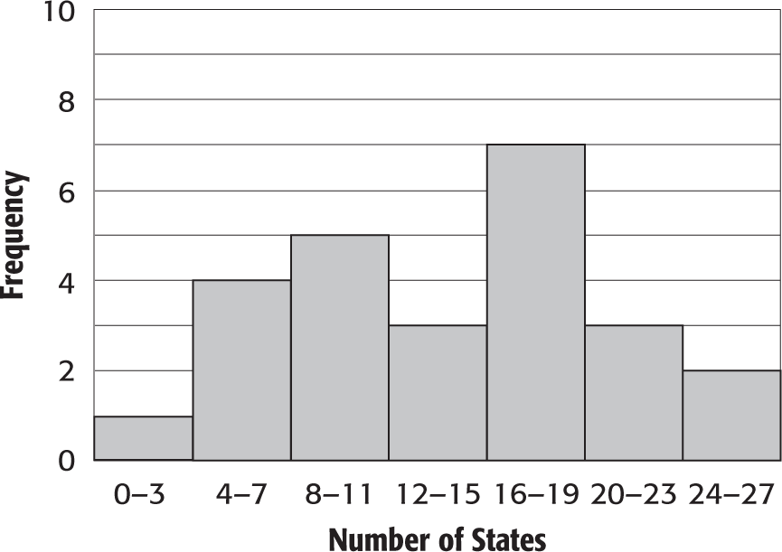

How many of Kylie’s classmates have visited more than 15 states?

F. 3 students

G. 8 students

H. 12 students

I. 15 students

37. What is the surface area of the triangular prism?
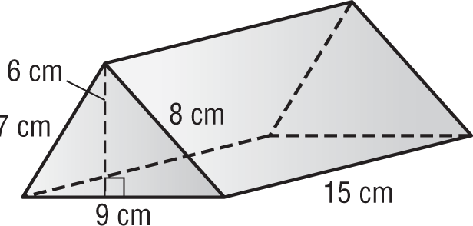

A. 468 square centimeters

B. 414 square centimeters

C. 405 square centimeters

D. 378 square centimeters

38. Which of the following represents the decimal 0.32 written as a fraction in simplest form?

F. $\frac{32}{100}$

G. $\frac{16}{50}$

H.$\frac{17}{50}$

I. $\frac{8}{25}$

39. SHORT ANSWER Jeremy can purchase a
1.2-pound package of ground beef for $4.55
or a 1.6-pound package for $6.30. Which is
the better buy? Explain your reasoning.

40. Pamela is the leading server on her volleyball team. On average, she serves an ace 44% of the time. If she attempts 25 serves in her next game, how many aces would you expect her to have?

A. 57 aces

B. 19 aces

C. 11 aces

D. 8 aces

Course 1 Benchmark Test – End of Year (continued)

41. What percent is represented by the model?

F. 175%

G. 125%

H. 75%

I. 25%

42. Which of the following best describes the center of a data set if there are outliers in the data but no big gaps in the middle of the data?

A. mean

B. median

C. mode

D. range

43. SHORT ANSWER Complete the function table.

Input (x) | Output (3x− 1)
1
2
3
4
5

44. What is the surface area of a square pyramid with base side lengths of 10 inches and a slant height of 14 inches?
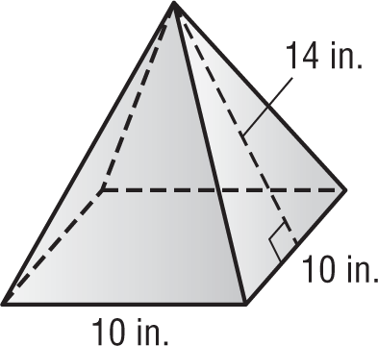

F. 220 ${ in}^{2}$

G. 280 ${ in}^{2}$

H. 380 ${ in}^{2}$

I. 660 ${ in}^{2}$

45. Which of the following properties would you use to solve the equation?

r + 4 = 11

A. Addition Property of Equality

B. Division Property of Equality

C. Multiplication Property of Equality

D. Subtraction Property of Equality

46. Which of the following inequalities is graphed on the number line?

F. x > 4

G. x ≥ 4

H. x ≤ 4

I. x < 4

Course 1 Benchmark Test – End of Year (continued)

47. SHORT ANSWER The box plot below shows the number of Calories in different lunches at a restaurant. Describe the shape of the distribution using symmetry and outliers.

Number of Calories
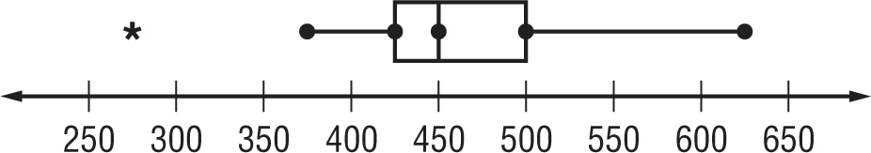

48. What is the area of trapezoid QRST?
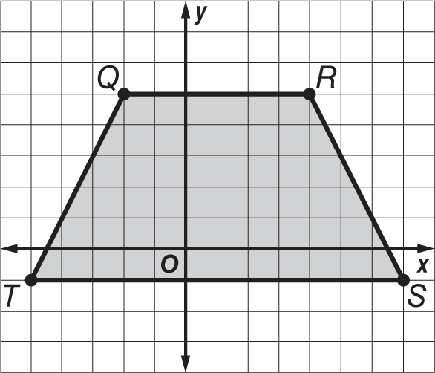

A. 54 square units

B. 68 square units

C. 76 square units

D. 108 square units

49. Mr. Addison is building a sandbox shaped like a rectangular prism. The sandbox is 8 feet long, 6 feet wide, and 1.5 feet deep. How many cubic feet of sand will the sandbox hold?

F. 15.5 cubic feet

G. 72 cubic feet

H. 105 cubic feet

I. 138 cubic feet

50. The Pirates football team has played 75% of its games so far this season. If the team has played 9 games, how many games are there in the season?

A. 7 games

B. 11 games

C. 12 games

D. 15 games

51. Which of the following expressions is equivalent to 3(4x + 1)?

F. 7x + 4

G. x + 4

H. 12x + 1

I. 12x + 3

52. What is the missing rule in the function table?
x | ?
2 | 7
3 | 8
6 | 11
9 | 14
12 | 17

A. $\frac{x}{-4}$

B. x + 5

C. –4x

D. x – 3

Course 1 Benchmark Test – End of Year (continued)

53. Which of the following expressions correctly uses exponents to show the prime factorization of 168?

F. $2^{4}$ × 3 × 7

G. $2^{3}$ × $3^{2}$ × 7

H. $2^{4}$ × $3^{2}$ × 7

I. $2^{3}$ × 3 × 7

54. SHORT ANSWER Which measure of center would you use to describe the center of the data shown on the line plot? Explain your reasoning.

Number of Pets
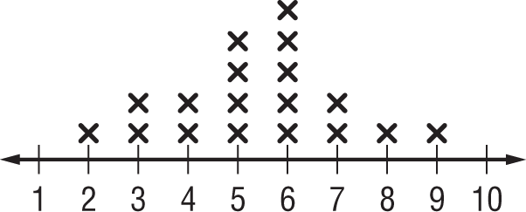

55. A pancake recipe calls for $\frac{1}{3}$ cup of mix for 4 pancakes. If Beth needs to make 60 pancakes,
how many cups of pancake mix will she need?

A. 5 cups

B. $4\frac{2}{3}$ cups

C. $3\frac{1}{3}$ cups

D. $\frac{1}{5}$ cup

