Test, Form 1B

Write the letter for the correct answer in the blank at the right of each question.

1. The manager of a hotel wants to know how often his customers rent boats at a nearby lake. Which sampling method will give valid results?
A. He asks every tenth customer who checks into the hotel.
B. He posts a question on the hotel’s Web site.
C. He randomly surveys households in the neighborhood.
D. He asks every customer in the hotel lobby at noon.

2. To survey a town about traffic concerns, Himani divided the town into eight
regions and randomly chose 10 households from each region. What type of
sample did she form?
F. simple random sample
G. systematic random sample
H. biased sample
I. convenience sample

3. Five out of seven teens said they do homework every night. What is a reasonable prediction for the number of teens out of 980 who would do homework every night?
A. 57 C. 350
B. 140 D. 700

4. Use the data set $8, $10, $15, $8, $12, $13, $8 and $11. Which measure of center would you use to convince people that the prices are low?
F. mean H. mode
G. median I. none of these

5. Which of the following is an appropriate display to show the prices of gasoline over the past 3 weeks?
A. bar graph C. circle graph
B. line graph D. histogram

6. Which of the following is an appropriate display to show the heights of buildings arranged by intervals?
F. bar graph H. circle graph
G. line graph I. histogram

SCORE __________

1.__________________

2. _________________

3. _________________

4. _________________

5. _________________

6. _________________

Test, Form 1B (continued) SCORE __________

7. The bar graph compares the number of students that received a grade of an A, B, C or D in Ms. Logan’s classroom. Which statement best tells why the graph could be misleading?
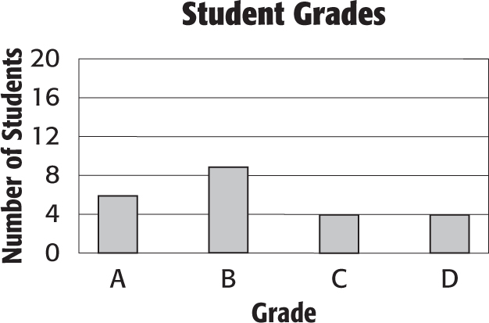
A. The intervals on the vertical axis are not equal.
B. The graph title is misleading.
C. The intervals on the vertical axis make it appear that the number of students that received each grade are nearly the same.
D. The graph should be a line graph.

8. The double line plot shows the number of students who attended the home games of the baseball team for two recent seasons.
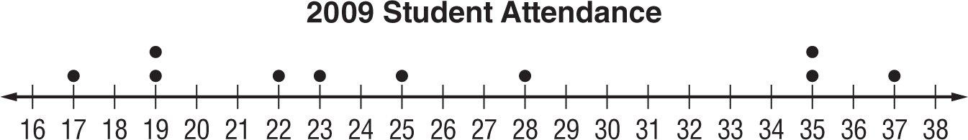

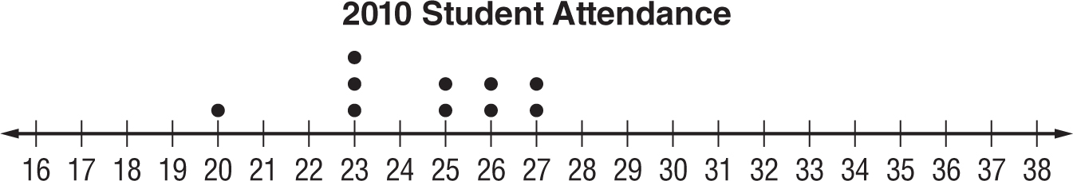

Which of the following statements is not true
F. The attendance for 2009 was more varied.
G. The attendance for 2010 was more consistent.
H. The attendance for 2009 peaked at 23 students.
I. The attendance for 2010 ranged from 20 to 27.

9. A survey showed that 90% of students would select roller coasters as their favorite ride at an amusement park. Out of 5,000 students, predict how many would select roller coasters as their favorite ride?
A. 4,500 C. 450
B. 500 D. 50

10. Which measure of center should you use to describe two data sets that are both symmetric?
F. mean H. median
G. mode I. range

7. _______________

8. _______________

9. _______________

10. _____________

