Test, Form 2B

Write the letter for the correct answer in the blank at the right of each question.

1. The double line plot shows the number of text messages 2 groups of students reported that they sent in one day.
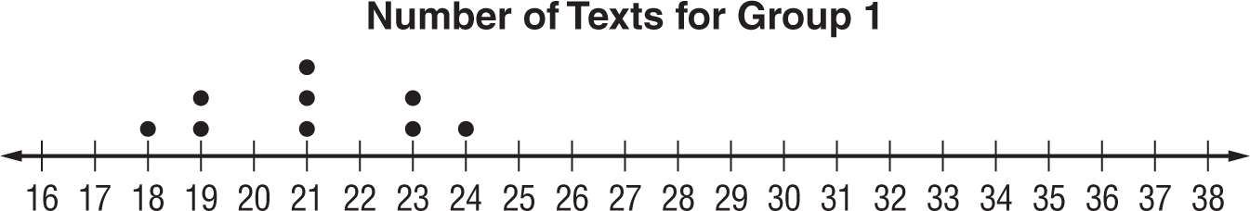

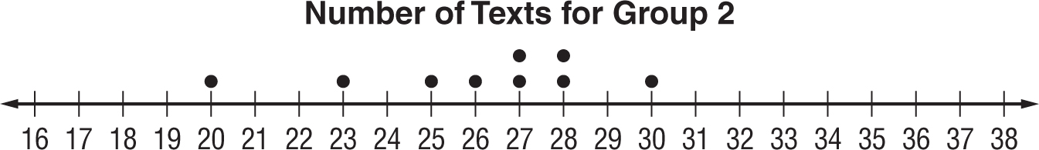

Which of the following statements is true?
A. The mean for group 1 is larger than the mean for group 2.
B. Group 2 has a greater median number of texts that were sent. Group 1 has a smaller interquartile range, so the data is less spread out.
C. The median for group 1 is larger than the median for group 2.
D. Both sets of data are symmetric. You should use the mean to compare the measures of center and the mean absolute deviation to compare the variations

2. A survey found that 3 out of 7 people in a community jog on a regular basis. If there are 3,150 people in the community, what is a reasonable prediction for the number of people who would jog regularly?
F. 1,050 H. 1,575
G. 1,350 I. 1,800

3. A survey found that 2 out of 8 students do not own a pet. If there are 480 students in a school, what is a reasonable prediction for the number of students who own a pet?
A. 360 C. 36
B. 120 D. 12

4. Which type of data display would be best for showing how the height of a plant changes each week during a science experiment?
F. line plot H. stem-and-leaf plot
G. bar graph I. line graph

SCORE __________

1._____________________

2. _____________________

3. _____________________

4. _____________________

Test, Form 2B (continued)

5. The table shows the number of hours Felisa spent sleeping each night for 12 nights Which type of data display would not be suitable for displaying the data?
Hours Spent Sleeping
8 | 6 | 7 | 8
10 | 8 | 8 | 6
6 | 8 | 8 | 7

A. line plot
B. bar graph
C. circle graph
D. line graph

6. The number of toys donated by students in 12 classes is shown below. The principal says the average number of toys donated by each class is 26. Explain how this could be misleading.

16, 16, 17, 19, 20, 23, 24, 25, 29, 31, 33, 59

7. To determine what park visitors like, every tenth visitor is surveyed at the park entrance. Out of 180 visitors, 22% said they would like to have more walking paths. The park manager concludes that about one-fifth of all park visitors would like to have more walking paths. Is this conclusion valid? Justify your answer.

8. Which measure of center should you use to describe two data sets that are both symmetric?

SCORE __________

5. _________________

6.__________________

7. _________________

8. _________________

