Ch 12 Statistical Displays Study Guide, Form 2B

Write the letter for the correct answer in the blank at the right of each question.

For Exercises 1-4, use the following line plot that shows the number of jumping jacks students completed in 30 seconds.
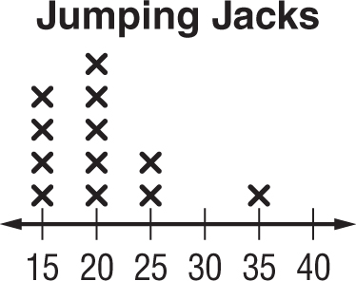

1. What is the mean, median and mode of the data? Round to the nearest tenth if needed.

2. What is the peak and gap in the data?

3. What would you use to describe the center of the data?
A. mean B. median C. mode D. range

4. What would you use to describe the spread of the data?
F. interquartile range H. gap
G. range I. mean absolute deviation

5. Which of the following is an appropriate display to show the average price of a postage stamp over the last 20 years?
A. line graph C. circle graph
B. bar graph D. histogram

For Exercises 6-8, use the box plot. It shows the number of days on the market for single family homes in a city.
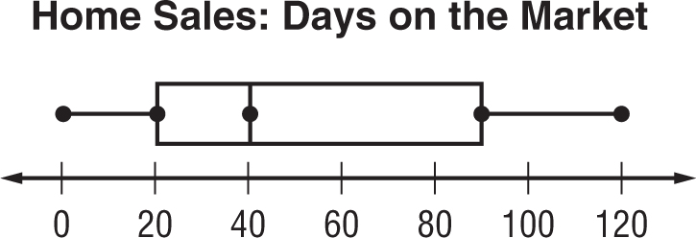

6. What is the median of the data?
F. 30 G. 40 H. 90 I. 120

7. What percent of the homes were on the market less than 90 days?
A. 0% B. 25% C. 50% D. 75%

8. What is the range and interquartile range of the data?

1. ____________

2. ____________

3. ____________

4. ____________

5. ____________

6. ____________

7. ____________

8. ____________

Ch 12 Statistical Displays Study Guide

For Exercises 8 and 9, refer to the histogram. It shows the prices of different calculators.
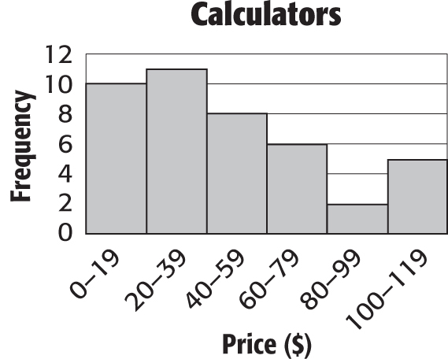

8. Which price range has the greatest frequency?
F. $100-$119 H. $80-$99
G. $20-$39 I. $11

9. How many calculators cost $80 or more?
A. 7 B. 6 C. 3 D. 2

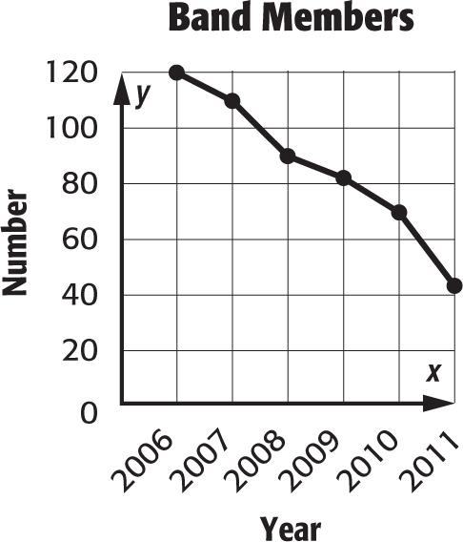
The line graph shows the number of band members in a high school for several years.

10. If the trend continues, what is the best prediction for the number of students that will be band members in 2012?
F. 25 H. 59
G. 45 I. 100

11. The number of toys donated by students in 12 classes is shown below. Find the measures of variation for the data set.

16, 16, 17, 19, 20, 23, 24, 25, 29, 31, 33, 38

12. Draw a box plot for the data in Exercise 11.
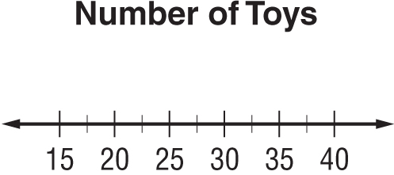

13. Jonez surveyed people about their favorite music. The results are shown in the table. Which type of display would be best to show the survey results?
Music | Students
Classical | 25
Country | 30
Rock | 30
Jazz | 15

8. _________________

9. _________________

10. ________________

11. median: _________
1st quartile: _________
3rd quartile: _________
Lower extreme: _____
Upper extreme: _____

12.

13. ________________

