Ch 11 Statistical Measures Study Guide, Form 2B

Write the letter for the correct answer in the blank at the right of each question.

The table shows the number of hours Ladena spent sleeping each night for 12 nights. Use the table to answer Exercises 1-3.
Hours Spent Sleeping
8 | 6 | 7 | 7
10 | 8 | 8 | 10
8 | 8 | 5 | 7

1. What is the mean of the data? Round to the nearest tenth.
A. 7.5 B. 7.6 C. 7.7 D. 8.2

2. What is the median of the data?

3. What is the mode of the data?

Refer to the dot plot to answer Exercises 4 and 5.
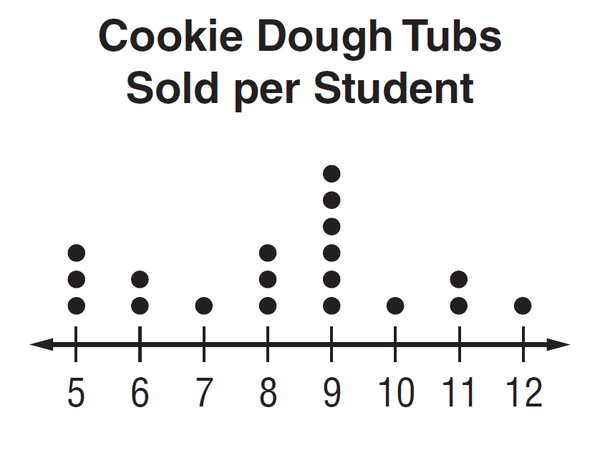

4. What is the median of the data?
F. 7 G. 8 H. 9 I. 10

5. What is the mode of the data?
A. 5 B. 7 C. 8 D. 9

6. Define each vocabulary word below.
F. third quartile H. interquartile range
G. first quartile I. range

1._______________

2. _______________

3. _______________

4. _______________

5. _______________

6.

Ch 11 Statistical Measures Study Guide

Use the table for Exercises 7-9.
Dress Costs ($)
38 | 50 | 32 | 42
50 | 32 | 75 | 50

7. What is the mean of the data?
A. $369 B. $46 C. $46.12 D. $46.13

8. Which measure of center best describes the data?
F. mean G. median H. mode I. range

9. What is the mean cost without the outlier? Show all work to find the outlier. Round to the nearest cent if necessary.
A. $29.40 B. $36.75 C. $38 D. $42

Exercises 10-12: Use the following set of data: 20, 28, 30, 6, 15, 18, 21, 22, 25, 29, 24, 26.

10. What are the first and third quartiles of the data?

11. What is the interquartile range of the data?

12. Are there any outliers in the data set? Show all work and limits.

13. Katherine earned 90, 84, 78, 88 and 85 on her first 5 tests. What is the minimum grade Katherine needs to earn on the next test to have a mean of 86? Show all work.

14. Which measure of center would you use to describe a data set with…
- no outliers _____________ - outliers _____________

7.______________

8. ______________

9. ______________

10. 1st: __________

3rd: __________

11. ______________

12. ______________

13. ______________

______________

