Functions Study Guide

1. Complete the function table at the right.

Write an EXPRESSION to describe the value of each term as a function of its position. Then find the twelfth term in each sequence.

2.
Position | 1 | 2 | 3 | 4 | n
Value of Term | 6 | 12 | 18 | 24

Position | 5 | 6 | 7 | 8 | n
Value of Term | -3 | -2 | -1 | 0

3.

Write an EQUATION to represent the function.
Input, x | 0 | 1 | 2 | 3
Output, y | -2 | 2 | 6 | 10

4. 5.
Input, x | 1 | 2 | 3 | 4
Output, y | -2 | -4 | -6 | -8

Use the following information for Exercises 6-9.

MONEY James save $3 each week in his piggy bank.

6. Write an equation to find y, the total amount of money James has in his piggy bank after each week, x.

7. Make a table to show the relationship between the number of weeks, x and the total amount of money, y for 1, 2, and 3 weeks.

8. Graph the ordered pairs (x, y) at the right. Label each axis.

9. How much money will James have after saving for 8 weeks according to the information above (the equation, chart and graph)?

___________________

1.
Input, x | 4x – 8 | Output, y
3
4
5

2. Rule:___________________

Twelfth term: _______________

3. Rule:___________________

Twelfth term: _______________

4. ___________________

5. ___________________

6. ___________________

Weeks, x
Total money, y
7.

8.
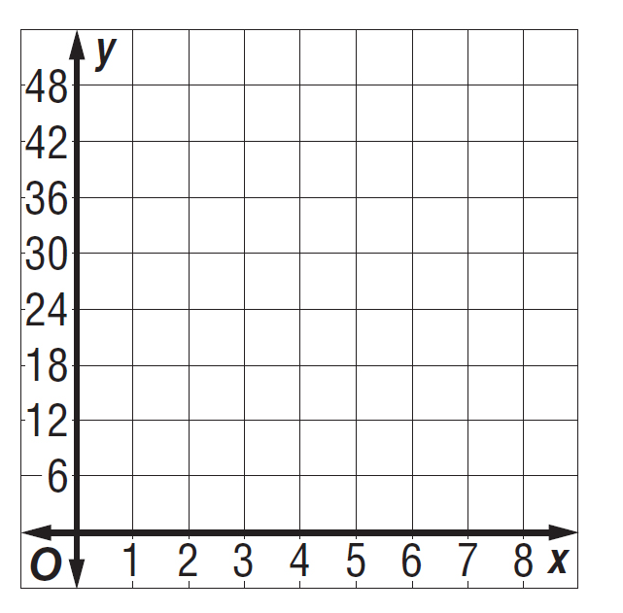

10. Find the input for the function table. Complete the table.

Input (x) | x ÷ 7 | Output (y) |  | Input (x) | 5x – 2 | Output (y)
 |  | 3 |  |  |  | 3
 |  | 5 |  |  |  | 13
 |  | 7 |  |  |  | 23

11. MEASUREMENT There are 24 hours in 1 day. Make a table and write a function rule relating the number of days (x) to the number of hours (y) for 1, 2, 3, and n days. Then find the number of hours in 9 days. Record all the data in the table.

Function Rule: ____________________________

12. Determine how the next term in this sequence can be found. Then find the next two terms in the sequence.

2, 19, 36, 53, ______, ______ How the next term is found: _____________________________________________

13. Find the missing number in this sequence.

22.2, 15.9, ______, 6, -0.3 …

14. Graph this equation: y = 2x + 2. List 3 ordered pairs you used to create the graph. Show your work.

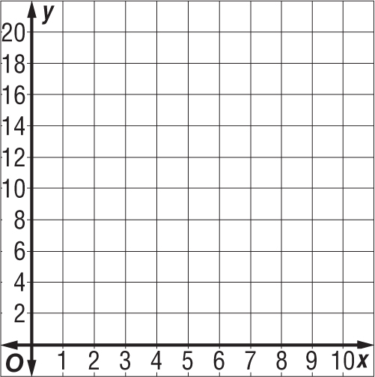
Ordered Pairs:

15. Extended Response In your own words, define what a mathematical sequence is. Along with your definition, provide examples of an arithmetic and a geometric sequence.

A sequence is…
An example of an arithmetic sequence is…
An example of a geometric sequence is…

