You must show all work that you typed into your calculator for credit.

1. In a certain area, there are 26 stores to 48 restaurants. Write the ratio of stores to 1. ________ restaurants as a fraction in simplest form. Then explain its meaning.

___________________________________________________________________________________

2. On his fruit stand, Mr. Roberts has 12 papayas, 21 star fruits, 27 mangos, and 2. ________ 18 strawberries. What is the ratio of the number of papayas to the total number of pieces of fruit? ________
Write the ratio in all 3 forms. ________

Write two unit ratios for each scenario.

3. 210 heartbeats in 30 seconds 3. ________, _______

4. 24 puzzles in 4 hours 4. ________, ________

5. 84 meters in 7 seconds 5. ________, ________

Use the ratio table given to solve the problem.
6. Ms. Sims traveled to 24 countries in 72 days. At this rate, how many countries would 6. ________ she travel to in 60 days?

Countries | 24
Days | 72 |  | 60

7. Determine if the rates $156 raised for washing 26 cars and $252 raised for washing 7. _________ 36 cars are equivalent. Explain your reasoning: ______________________________________

____________________________________________________________________________

8. Dylan read 12 pages of a novel in 5 minutes. At the same rate, how many pages 8. _________ can he read in 7 minutes? Show your work.

9. Erica can bike 18 miles in 4 hrs. How fast did she bike in miles per hour? Show your work. 9. _________

10. Tina walks at a rate of 150 feet per minute. How many feet per second does Tina walk? Show your work. 10.______
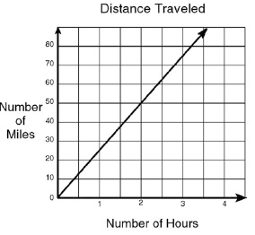
11. What does the point (1, 25) on the graph represent? (1 pt) 11. _________

12) The cost of ordering hamburgers is shown in the table below.
Hamburgers | 2 | 3 | 4 | 5
Cost $ | 5 | 10 | 15 | 20
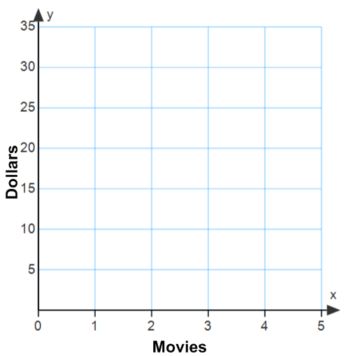
a) Does the table show a proportional relationship? Explain.

b) Graph the data from the table to the right.
c) How does the graph support your answer from part a?
Tacos Ordered

Hours | Pages Read
4 | 100
13) Complete the ratio table to show a constant rate of change.

14) Sally and Maggie work at the hardware store. The wages earned for the weekend are shown in the table and graph below. Who gets paid more per hour? Show your work and explain how you determined your answer.
Maggie’s Earnings Work and explanation:
Sally’s Earnings
Time (h) | Earnings($)
2 | 52
4 | 104
6 | 156
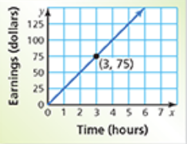

15) Determine if the relationship is a proportional relationship. Write “proportional” or “nonproportional” and explain your reasoning.
Hours | 5 | 10 | 15 | 20
Cost $ | 75 | 150 | 210 | 280

15. _________

Bonus) 65 centimeters per second is equivalent to how many meters per minute? _____________

