STUDY GUIDE: Rational Numbers and the Coordinate Plane Name: ____________________ Date: _______ Block: _____
D: ________ P: ________ 1. Write $\frac{17}{25}$ as a decimal and a percent.

D: ________ P: ________ 2. Write − $\frac{8}{11}$ as a decimal and a percent.

D: ________ P: ________ 3. Jake won 13 of the 15 races he ran. Write Jake’s fraction of wins as a decimal and a percent.

________ 4. Use <, > or = to compare the rational numbers. $52.9$2 ⃝ $52.902$

________ 5. Order − 8.6, 8$\frac{5}{9}$, −8$\frac{7}{12}$, and 8.$\overline{4}$ from least to greatest.

________________________________________ 6. Order $-4\frac{1}{4},\left|-4\right|,-4\frac{3}{11},-4.\overline{30}$ from least to greatest.

F: ________ P: ________ 7. Write 0.048 as a fraction in simplest form and a percent.

________ 8. Write -3.415 as an improper fraction in simplest from.

F: ________ D: ________ 9. Write 48% as a fraction in simplest form and a decimal.

F: ________ D: ________ 10. Write 0.65% as a fraction in simplest form and a decimal.

F: ________ D: ________ 11. Write 185% as a fraction in simplest form and a decimal.

________ 12. Find the distance between (-7, 4) and (-7, 9).

________ 13. Find the distance between (5, -9) and (5, 2).

________ 14. Which of the following correctly identifies the quadrant where the point named by ($-$9, 3) is located?
F. Quadrant I H. Quadrant III
G. Quadrant II I. Quadrant IV

Graph each point on a coordinate plane to the right. (Write the letter beside the point on the coordinate plane.) Then identify which quadrant or axis the point is in/on.

15. P (−3, 4), Quadrant _____
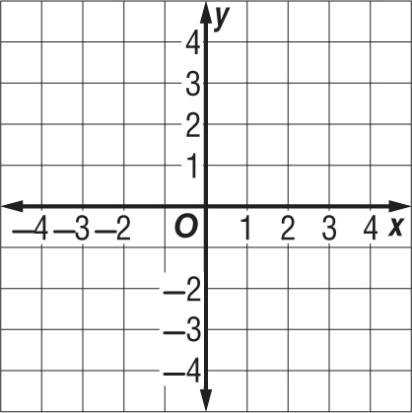

16. Q (2, −4), Quadrant _____

17. R (3, 0), Quadrant _____

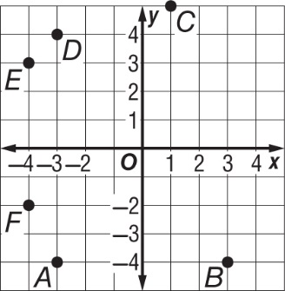
For Exercises 18-19, use the coordinate plane at the right.

________ 18. Identify the point for the ordered pair (−4, 3).

(____,____) 19. Write the ordered pair that names point A.

The coordinate plane at the right shows the location of the YMCA. For Exercises 20-22, you may graph on the coordinate plane, but write your ordered pair answers in the blank.

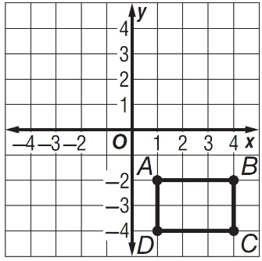
(____,____) 20. An oak tree is located at the reflection of point C across the y-axis. What ordered pair describes the location of the oak tree?

(____,____) 21. A sprinkler is located at the reflection of point A across the x-axis. What ordered pair describes the location of the sprinkler?

(____,____) 22. A fire pit is located at the reflection of point B about the y-axis. What ordered pair describes the location of the fire pit?

