Name:_____________________________ Unit 1 - Area and Surface Area Study Guide

- The net of the rectangular prism is shown below. What is the surface area, in square centimeters, of the figure shown in the net?
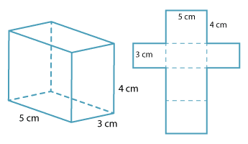

- What is the area, in square units, of the triangles below?
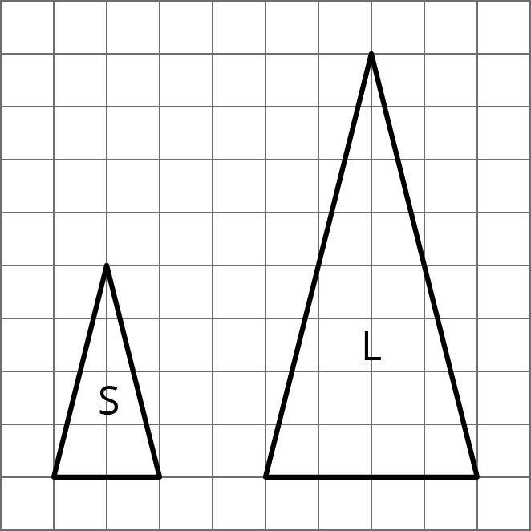

a.) What do you notice about the change in base and height from triangle S to triangle L?

b.) What do you notice about the area of triangle S compared to the area of triangle L? Why do you think this is?

- The measurements for the parallelogram are given in meters. What is the area of this parallelogram, in square meters?
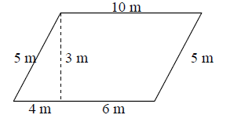
- Jake’s joy kite is shown with side lengths labeled. What is the area of his kite?
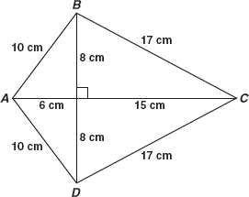

- The net of a triangular pyramid and a square based pyramid are shown. The pyramids will be constructed by these patterns but it will not have a base. What is the surface area of the faces of each pyramid? Record your answers in square inches.
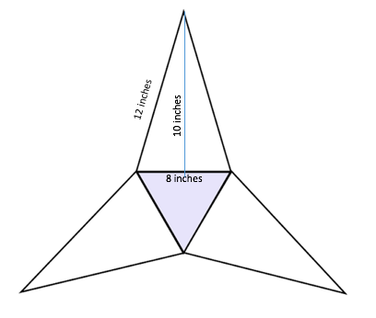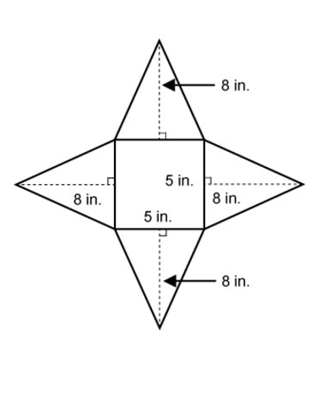

- What is the area of the figure below?
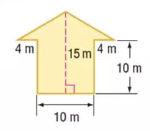
- What is the area, in square feet, of the figure below?
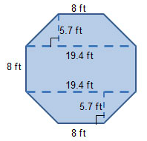
- What of the areas of the triangles below?
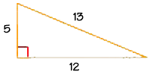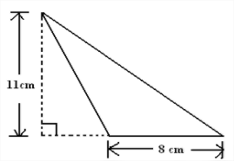
- What is the area of a parallelogram with a base of 4.5 inches and a height of 6 inches?

- What is the area of a triangle with a height of 9 feet and a base of 14 feet?

- What is the area of a trapezoid with base measures of 6 centimeters and 8 centimeters and a height of 3 meters?

- What is the surface area of a cube with edge lengths of 8 inches?

- If the area of triangle BCD is 48 square units, what is the area of rectangle ABCD?
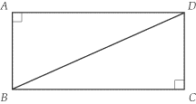
- What is the surface area of the rectangular prism?
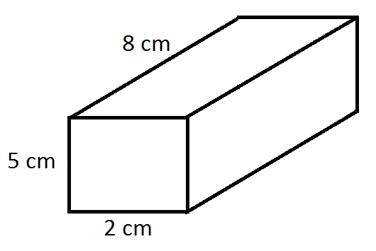

- What is the area, in square units, of the shaded parallelogram below?
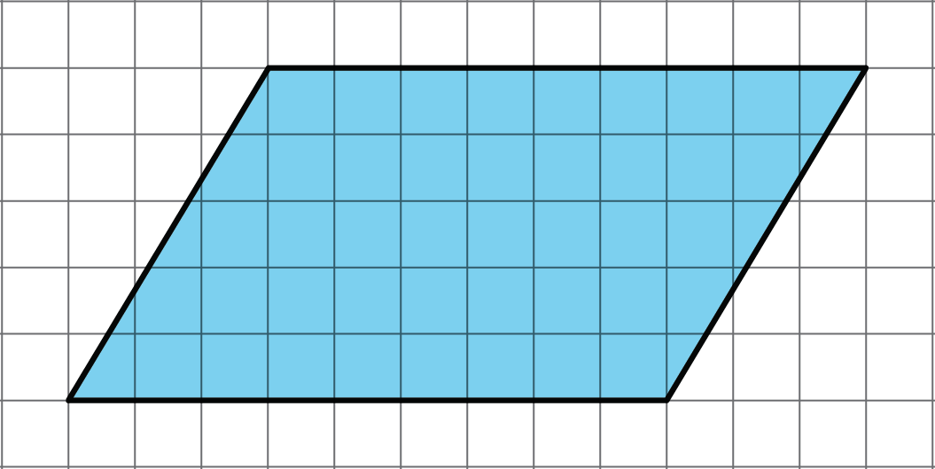

- What is the surface area of each triangular prism?
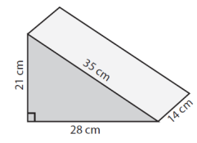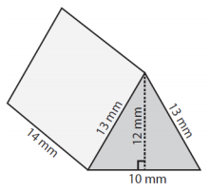
- Name the 3-dimensional figure that can be created by folding each net.

A B C D E F
