Volume Assessment 2017 [1518267]
Student
Class
Date

1. | What is the volume of this triangular right prism?  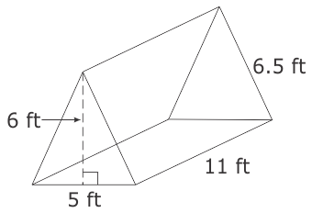
 | A. 165 ft³
 | B. 330 ft³
 | C. 1,073 ft³
 | D. 2,145 ft³

2. | The net below can be folded to make a solid figure.  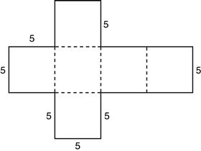  What is the volume, in cubic units, of the figure made by folding the net?
 | A. 150
 | B. 125
 | C. 70
 | D. 25

3. | The square pyramid below has a height of 18 mm.  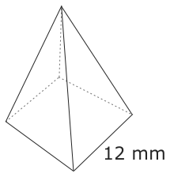  What is the volume of the square pyramid?
 | A. 864 mm³
 | B. 1,080 mm³
 | C. 2,592 mm³

4. | The figure below is a triangular prism.  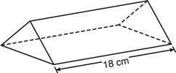  What is the volume of the prism if the area of its base is 14 square centimeters?
 | A. 32 cubic centimeters
 | B. 126 cubic centimeters
 | C. 252 cubic centimeters
 | D. 324 cubic centimeters

5. | What is the volume, in cubic yards, of a pyramid that has a height of 10 yards and a square base that measures 3 yards on each side?
 | A. 15
 | B. 30
 | C. 60
 | D. 90

6. | 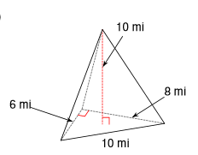 Find the volume of the triangular pyramid in cubic miles.
 | A. 240
 | B. 80
 | C. 400
 | D. 480

7. | 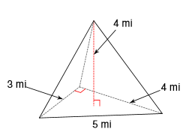Find the volume of the triangular pyramid in cubic miles.
 | A. 80
 | B. 48
 | C. 24
 | D. 8

8. | A rectangular prism has a length of 8 cm, a height of 2 cm and a volume of 96 cubic centimeters. What is the width of the rectangular prism?
 | A. 6 cm
 | B. 3 cm
 | C. 12 cm
 | D. 4 cm

9. | The base of a triangular prism has an area of 20 cm². The volume of the prism is 220 cubic centimeters. What is the height of the triangular prism?
 | A. 22 cm
 | B. 6 cm
 | C. 5.5 cm
 | D. 11 cm

10. | A storage unit, in the shape of a right rectangular prism, has dimensions of 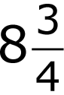 feet by 16 feet by 24 feet. What is the volume of the storage unit?
 | A. 164 feet³
 | B. 393 feet³
 | C. 3,072 feet³
 | D. 3,360 feet³

