Volume STUDY GUIDE Name: ______________________________ Block: ____

1. A rectangular hat box has a volume of 5,184 cubic inches. The box is 2 feet long by 18 inches wide. What is the hat box’s height?
F. 1 in. G. 12 in. H. 72 in. I. 144 in.

2. What is the volume of the right triangular prism?
A. 64 $m^{3}$
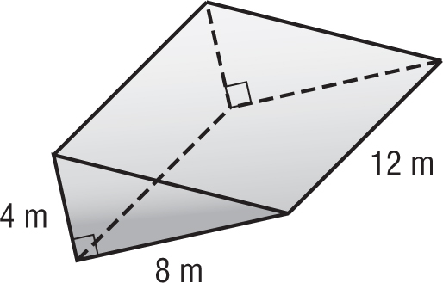
B. 128 $m^{3}$
C. 192 $m^{3}$
D. 384 $m^{3}$

3. A right rectangular prism is shown. What is the volume of the prism?

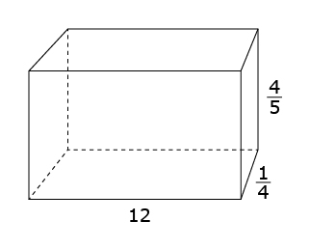
- 1$\frac{1}{5}$
- 2$\frac{2}{5}$
- 4$\frac{4}{5}$
- 13$\frac{1}{20}$

For Exercises 4-5 find the volume of each figure. Round to the nearest tenth if necessary.

4. 5.
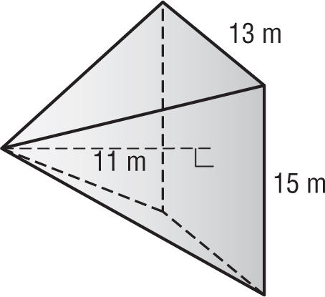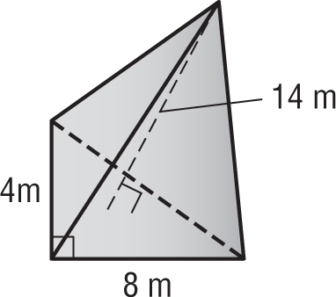

6. A storage shed with a flat roof is 4 yards long by 3 yards wide by 1$\frac{1}{2}$ yards tall. A cubic yard is equal to 27 cubic feet. How many cubic feet of storage space does the shed enclose?

7. A right rectangular prism has edge lengths of 1$\frac{1}{2}$cm, 3$\frac{3}{4}$cm and 2cm. How many cubes with $\frac{1}{2}$cm edge lengths would be needed to fill the prism completely?

8. A triangular prism has a base area of 18$\frac{1}{2}$cm² and a height of 3$\frac{1}{4}$cm. What is the volume of the prism?

A. 20$\frac{1}{24}$cm³
B. 21$\frac{3}{4}$cm³
C. 30$\frac{1}{16}$cm³
D. 60$\frac{1}{8}$cm³

9. A freezer is shaped like a rectangular prism. It has a length of 8 feet and a height of 3 feet. The volume is 54 cubic feet. Find the width of the freezer.
10. The right rectangular prism below is made up of 30 cubes. Each cube has an edge length of $\frac{4}{3}$ inches.

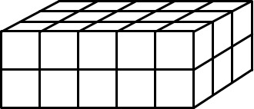
What is the volume of this prism?
- 2$\frac{10}{27}$ cubic inches
- 13$\frac{1}{3}$ cubic inches
- 30 cubic inches
- 71$\frac{1}{9}$ cubic inches

11. The side lengths of Cube 1 are $\frac{1}{4}$ inch. The side lengths of Cube 2 are 3 inches. How many Cube 1’s would be needed to fill Cube 2?
Cube 1 Cube 2

12. A rectangular prism has a volume of 84 cubic inches and a height of 7 inches. Which choice could be the length and width of the rectangular prism?
A. length: 4in width: 8in
B. length: 12in width: 12in
C. length: 3in width: 4in
D. length: 3in width: 9in

13. Find the volume of the composite figure.

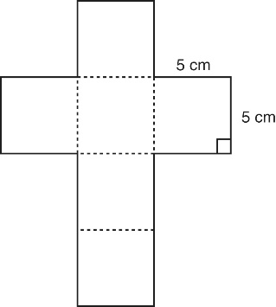
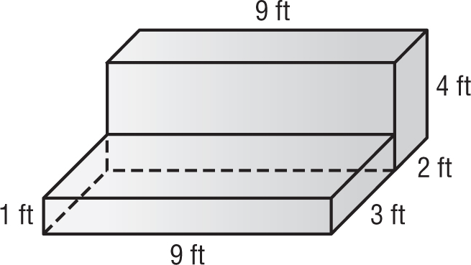

14. Landen drew a net of a cube, as shown to the right. What is the volume of the cube?

15. A triangular pyramid has a base area of 27cm² and a height of 12cm. What is the volume of the pyramid?

16. A rectangular prism has two square faces. The perimeter of one square face is 24cm. The height of the prism is 14cm. What is the volume of the prism?

17. Shrivya has a jewelry box that measures 6 inches by 8 inches by 5 inches. It contains a ring box that takes up about 10% of the jewelry box. What are possible dimensions of the ring box?
A. 3in by 3in by 3in
B. 1in by 2in by 4in
C. 2in by 3in by 4 in
D. 4in by 8in by 12in

18. The volume of a triangular prism is 384mm³. The area of the base is 32mm². What is the height of the prism?
A. 12mm B. 24mm C. 36mm D. 354mm
19. A company sells individual brownies in small boxes with dimensions 4 inches x 3 inches x $\frac{1}{2}$ inch. These individual boxes are shipped in a larger box with dimensions 1 foot x 8 inches x 10 inches. How many individual brownie boxes will fit in each shipping box?

20. A prism has a square base with a side length of 5$\frac{1}{2}$ feet. The height of the prism is 8 feet. What is the volume of the prism?

21. Mrs. Burns makes candles. She wants molds in the shape of a rectangular prism that holds 120 cubic centimeters of melted wax. She has a choice of 5 containers. Select all containers that Mrs. Burns could use. Pick up to 3 answers.
A. 8.5cm by 4cm by 3cm
B. 2.5cm by 6cm by 8cm
C. 4cm by 7.5cm by 4cm
D. 5cm by 4cm by 6.5cm
E. 3cm by 10cm by 4cm

22. Makaela makes her own soap. She stores the soap in individual boxes inside a large plastic container. The dimensions of the individual boxes are 4cm by 4cm by 2.5cm. If Makaela has 15,000 cubic centimeters of space in the large plastic container, how many bars of soap should she be able to store?

23. Find the height of a square pyramid that has a volume of 324 cubic inches and a base edge of 6 inches?

24. A square prism has a base area of 12$\frac{3}{4}$in². The height of the prism is 4$\frac{1}{2}$in. What is the volume of the prism?

25. What is the volume of the figure?
